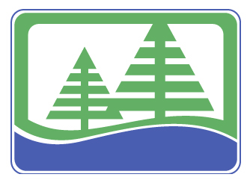
Wood Pawcatuck Watershed Association
To Protect and Preserve the Lands and Waters of the Wood Pawcatuck Watershed

Upper Pawcatuck River Fish Passage Restoration Project

Recently the Upper Pawcatuck River Fish Passage Restoration Project was awarded funding through the American Recovery and Reinvestment Act (ARRA) to support Rhode Island river ecosystem restoration efforts in the Pawcatuck and Ten Mile Rivers. The grant, administered through the National Oceanic and Atmospheric Administration, was awarded to the Rhode Island Coastal Resources Management Council (RICRMC) and will allow Wood Pawcatuck Watershed Association (WPWA) and its partners to complete construction at the Lower Shannock Falls and the design and construction activities at the remaining two upstream barriers at Horseshoe Falls and Kenyon Mill Dam.

Restoring Diadromous Fish to the Pawcatuck River: WPWA is working with local, state, federal, and private partners to provide fish passage and restore the river to more natural conditions in the upper Pawcatuck River and its watershed. Completion of the project will allow river herring and other migratory fish (e.g., American shad, American eel, and brook trout) access to spawning and rearing habitat in the upper Pawcatuck, Beaver, and Usquepaug Rivers, as well as the glacial lake that is Worden Pond.

In 2007, the engineering firm of Milone and MacBroom, Inc., completed a fish passage feasibility study to consider fish passage alternatives at the Lower Shannock Falls, Horseshoe Falls, and Kenyon Mill dams. This study is available by visiting www.wpwa.org. Following this extensive study, removal of the Lower Shannock Falls Dam and Kenyon Mill Dam was recommended by the firm, and construction of a Denil fish ladder at the Horseshoe Falls Dam was recommended due to its historic and aesthetic significance. WPWA is currently working to implement dam removal at the Lower Shannock Falls Dam in mid 2010 and is preparing to initiate design at the remaining two barriers.

Project Benefits: Fish passage in the upper Pawcatuck will restore the river to a more natural condition by,
- Allowing migratory fish access to approximately 1300 acres of upstream spawning and nursery habitat within the upper Pawcatuck watershed, including Worden Pond valuable for alewife spawning.
- Increasing food supply for many recreational and commercial fish species, including striped bass, bluefish, and summer flounder
- Restoring river connectivity for resident fish, wildlife, and people
- Restoring a more natural floodplain and riparian (riverbank) habitat
- Providing additional flood storage area
- Improving recreational fishing, boating and wildlife viewing opportunities on the river
- Removing financial burdens and liability for dam owners (in the case of removal)
- Contributing to maintaining or creating jobs through engineering, design, and project implementation
Lower Shannock Falls Removal: WPWA is partnering with the Town of Richmond to remove this degraded dam in Shannock Village. Following removal (scheduled for fall 2009), Richmond will construct the Knowles Mill public park bordering the dam removal site. The park will provide various recreational opportunities including fishing and boating access in addition to memorializing the history of the site with interpretive signs.

Horseshoe Falls Fishway: WPWA is preparing to enter into a contract with an engineering firm to complete design and construction of a structural fish ladder at the Horseshoe Falls Dam. Conceptual plans include a Denil fish ladder on the southeast side of the river with a natural stone façade to blend with the beauty of this regionally recognized dam. Potential dam repair will be evaluated during design and the project is supported by the dam’s owner.

Kenyon Mill Dam Removal: WPWA is preparing to enter into a contract with an engineering firm to complete design and construction of a dam removal project at the Kenyon Mill Dam. WPWA is thoroughly investigating any potential impacts to the project site and associated upstream and downstream water resources before selecting a final design. The dam is owned by Kenyon Industries who are in support of the project. The preferred project design for the Kenyon Mill Dam removal will result in no significant negative effects on upstream water resources, including Worden Pond, or the fish and wildlife that rely on it. Additional alternatives, including a rock ramp or other river channel modifications, will be evaluated as necessary. Specifically, WPWA and its partners are investigating potential effects on:

- Upstream water resources, including wetland resources and Worden Pond
- Rare, threatened, or endangered plants or animals
- Historic resources
- Private and municipal wells
- River flow rates
- Fire suppression needs (in coordination with Kenyon Industries, the Richmond-Carolina and Charlestown Fire Departments)
- Recreational impacts and benefits

Partnership Effort: The overall project is a collaborative effort between local, state, federal and private agencies, including:
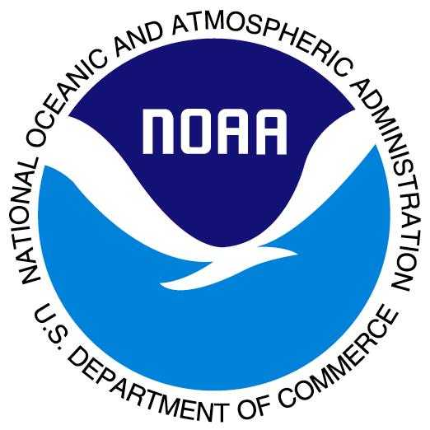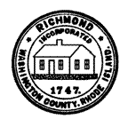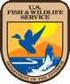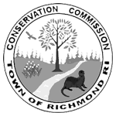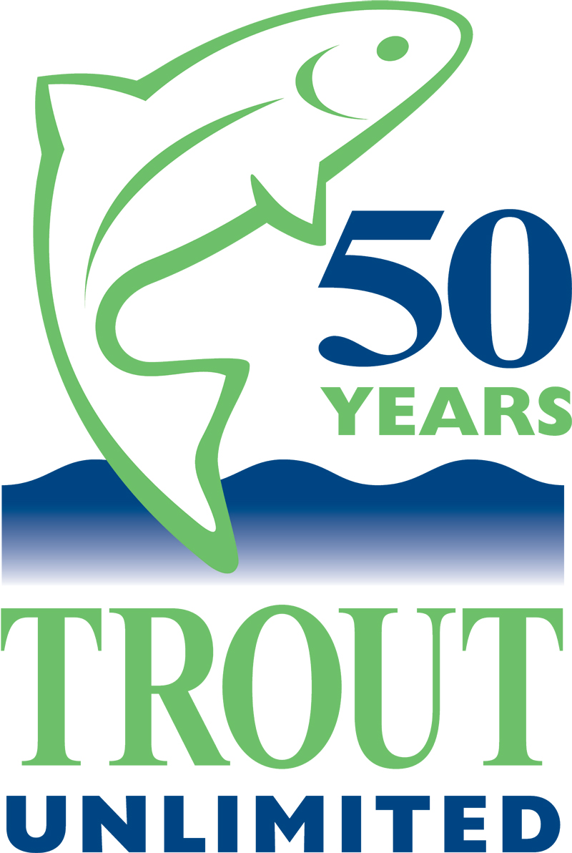
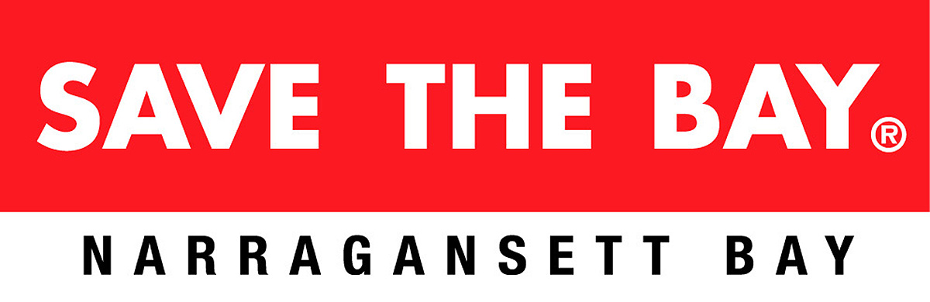

Please direct any project questions to Chris Fox, Executive Director, Wood Pawcatuck Watershed Association at (401)539-9017 or chris@wpwa.org.

